 | 12.1.40 Editors - Geometry Nodes Editor - Header - Add Menu - Utilities
Table of content
Detailed table of content 1
Add menu - Utilities 2
Random Value 2
Switch 3

Detailed table of content
Detailed table of content
Detailed table of content 1
Add menu - Utilities 2
Random Value 2
Input 2
Min 2
Max 2
ID 2
Seed 2
Properties 2
Data Type 2
Output 2
Value 2
Switch 3
Inputs 3
Switch 3
A 3
B 3
Properties 3
Input Type 3
Outputs 3
Output 3

Add menu - Utilities
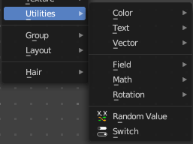
Utility nodes are mainly for mathematical operations.

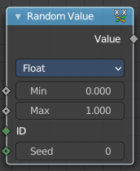
Random Value
Generates a random value.

Input

Min
The minimum value of the range. This input is only available for Float, Integer, and Vector types.

Max
The maximum value of the range. This input is only available for Float, Integer, and Vector types.

ID
An ID to drive the random number generator seed. By default, this input uses the same value as if the ID Node, which is the id attribute of the context geometry if it exists, and otherwise the index.

Seed
The random seed for the random number generation.

Properties

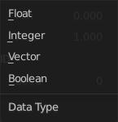
Data Type
What kind of random value to create. The items should be self explaining.

Output

Value
The output value.

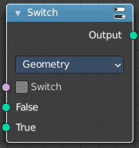
Switch
Switch between two inputs values based on a boolean.

Inputs

Switch
The boolean switch.

A
The input value A. Used when the switch is off.

B
The input value B. Used when the switch is on.

Properties

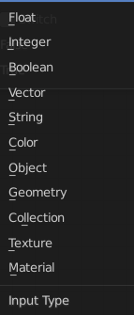
Input Type
What input type the values are, which defines what type to output then.

Outputs

Output
Numerical value output.

